|  |
| --- |
| < Traffic Penalty Management Software> User Manual |
| Group members:Thi Ngoc Nhu Nguyen – s5325919James Odike – s53310032810ICT Software TechnologiesOctober 8, 2023 |

Our software is a traffic penalty management website showing information of all offences in New South Wales such as the offence code, offence description, the financial year of the penalty notice, the penalty amount, etc. It can analyse each offence to show its trend over time, the places where offences are usually committed. Additionally, users can get information on penalty cases within a selected period and filter the data to serve their purposes. This User Manual document aims to provide you with an understanding of how to use the website as well as its features.

This website does not require an account to view and use it so users do not need to register an account.

**Navigation:** You can use the button navigation menu to assess different parts of the website comprising Penalty cases, Case distribution and Analytics.

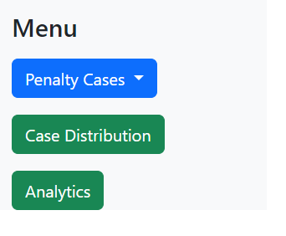

**Penalty cases:** The initial page is the penalty cases page. On this page, we show the list of details of penalty cases. Users can enter the from date and to date to view the penalty cases from the selected time range. Moreover, users can narrow down the results based on specific requirements. They can search the penalties by their offence code or type of that offence, for example, input seatbelt for seatbelt-related violations, or parking, mobile phone, and speed, … in the search bar. To further utilise the information of all cases of traffic violations, users can filter the data if the penalty is captured by radar, camera or lidar by clicking the dropdown menu in the penalty cases button.

**Case distribution:** To show the distribution of each offence, users must input the offence code in the “Enter the offence code” box. The websites then present the graph of that offence code’s distribution from the first financial year of the penalty notice until the latest financial year. To show the graph in a specific range of time, users can enter the from date and to date to shrink the results.

**Analytics:** On this page, there are two options for offence type which are Mobile phone usage and Exceed speed offences due to time limit and knowledge gap. We will develop more options in the future. Users can select an option to see more information about that violation type to gain a better understanding of the data. It will have a list of all offences in that type of violation and their details including offence code, offence description, the financial year, the fine, etc. Moreover, it will show the trend of that violation type over the years and locations where penalties happened.